|  |
| --- |
|  |
| The Documentation |
| [Type the document subtitle] |
|  |
| **[Your Name]** |
| **[Pick the date]** |

[Type the abstract of the document here. The abstract is typically a short summary of the contents of the document. Type the abstract of the document here. The abstract is typically a short summary of the contents of the document.]

Table of Contents

[To update the table of contents, right click the message below and select Update Field (F9 on PC, ⌥⌘U on Mac).]

1. Pages 4

1.1. Page Tree 4

1.2. Login Page 5

1.2.1. User Interface 5

1.2.2. Widget Table 5

1.3. Forgot Password? 7

1.3.1. User Interface 7

1.3.2. Widget Table 7

1.4. New User Registration 9

1.4.1. User Interface 9

1.4.2. Widget Table 9

1.5. Product Selection 11

1.5.1. User Interface 11

1.5.2. Widget Table 11

1.6. Medical Questionairre 13

1.6.1. User Interface 13

1.6.2. Widget Table 13

1.7. Billing Information 15

1.7.1. User Interface 15

1.7.2. Widget Table 15

1.8. Bank Account 17

1.8.1. User Interface 17

1.8.2. Widget Table 17

1.9. Credit card 19

1.9.1. User Interface 19

1.9.2. Widget Table 19

1.10. Review & Submit 21

1.10.1. User Interface 21

1.10.2. Widget Table 21

1. Pages
   1. Page Tree

Login Page  
Forgot Password?  
New User Registration  
Product Selection  
Medical Questionairre  
Billing Information  
 Bank Account  
 Credit card  
Review & Submit

* 1. Login Page
     1. User Interface

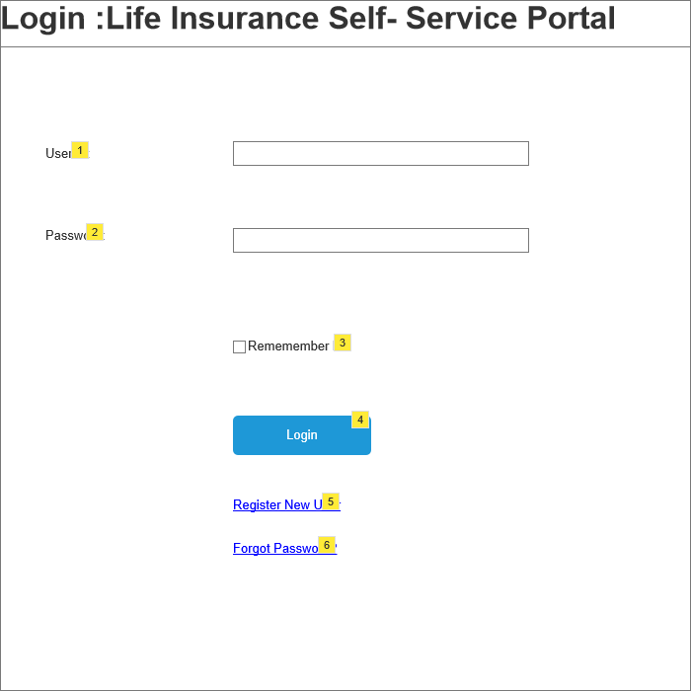

* + 1. Widget Table

|  |  |  |  |
| --- | --- | --- | --- |
| Note number | Name | Interactions | Note |
| 1 | User ID: Text Box |  | Required Field  Alpha numeric data  Min char 8  Max char 16 |
| 2 | Password: Text box |  | Required field  Alpha numeric data  Min char 8  Max char 16  Data is encrypted |
| 3 | Remember me: Check box |  | Optional field |
| 4 | Login: Command Button |  | On click if all validation pass display product selection page else display error message |
| 5 | Register New User : Hyper Link |  | On click display New User Registration page. |
| 6 | Forgot Password : Hyper Link |  | On click discard all the entered data and display Forgot Password? page |

* 1. Forgot Password?
     1. User Interface

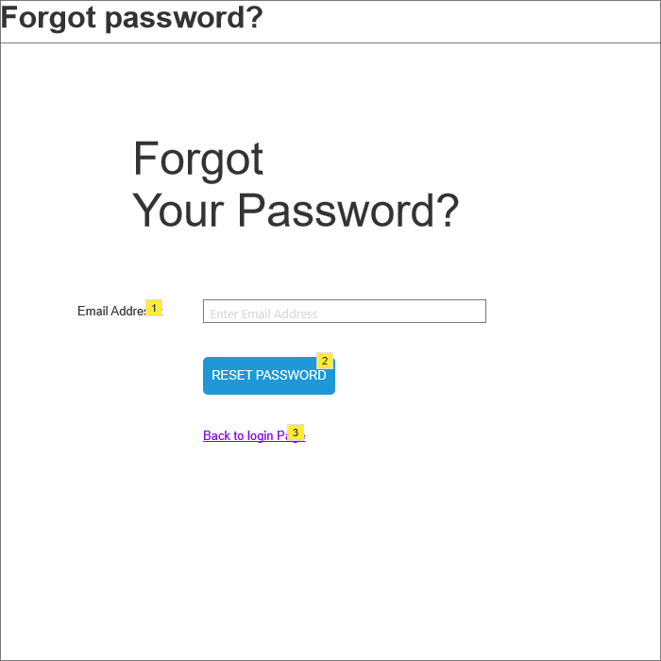

* + 1. Widget Table

|  |  |  |  |
| --- | --- | --- | --- |
| Note number | Name | Interactions | Note |
| 1 | Email Address : Text Box |  | Required Field  Alpha Numeric and spacial charracters Data  Min Char 8  Max char 56 |
| 2 | RESET PASSWORD : Command Button |  | On click if all validation pass display Login page else display error message |
| 3 | Back to Login page : Hyper Link |  | On click discard all the entered data and display Login page. |

* 1. New User Registration
     1. User Interface

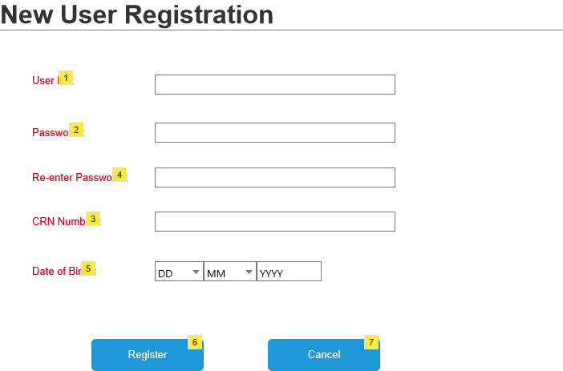

* + 1. Widget Table

|  |  |  |  |
| --- | --- | --- | --- |
| Note number | Name | Interactions | Note |
| 1 | User ID: Text Box |  | Required Field  Alpha Numeric Data  Min. char 8  Max. char 16 |
| 2 | Password: Text Box |  | Required Field  Alpha Numeric Data  Min. char 8  Max. char 16  Data is encrypted |
| 3 | CRN Number: Text Box |  | Required Field  Numeric Data  Min. char 9  Max. char 9  First five char is encrypted |
| 4 | Re-enter Password: Text box |  | Required Field  Alpha Numeric Data  Min. char 8  Max. char 16  Data is encrypted |
| 5 | Date of Birth*: Drop down and Text box |  | Required Field  Numeric Data  Select one from DD  Select one from MM  Numeric Data Max char 4 in YYYY section |
| 6 | Register : Command Button |  | On click if all validation pass display product selection page else display error message |
| 7 | Cancel: Command Button |  | On click discard all the entered data and display log in page |

* 1. Product Selection
     1. User Interface

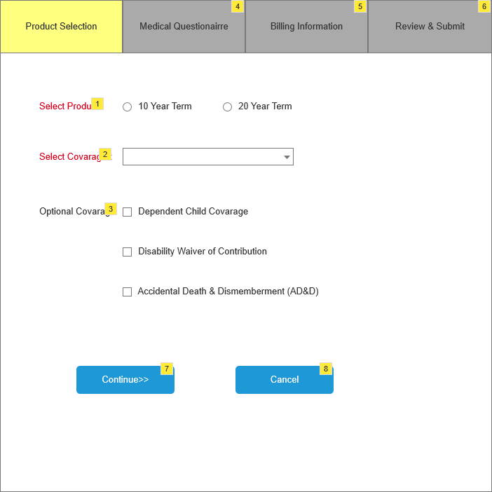

* + 1. Widget Table

|  |  |  |  |
| --- | --- | --- | --- |
| Note number | Name | Interactions | Note |
| 1 | Select Product*: Radio button |  | Required Field  options are 10 year term/ 20 year term  No default selection  Select one at a time |
| 2 | Select Covarage*: Drop down |  | Requierd Field  options are given  No default selection |
| 3 | Optional Covarage : Check box |  | Optional Field  Options are Given  NO default selection  Can choose more than one |
| 4 | Medical Questionairre : Text Box |  | Can not go to this page without selecting required data and continuing Product selection page |
| 5 | Billing Information : Text box |  | Can not go to this page without filling required data and continuing on Product selection page and Medical Questionairre page |
| 6 | Review & submit*: Text Box |  | Can not go to this page without filling required data and continuing on Product selection page and Medical Questionairre page and Billing information page |
| 7 | Continue>> : Command Button |  | On click if all validation pass display Medical questionairre page else display error message |
| 8 | Cancel : Command Button |  | On click discard all the entered data and display log in page |

* 1. Medical Questionairre
     1. User Interface

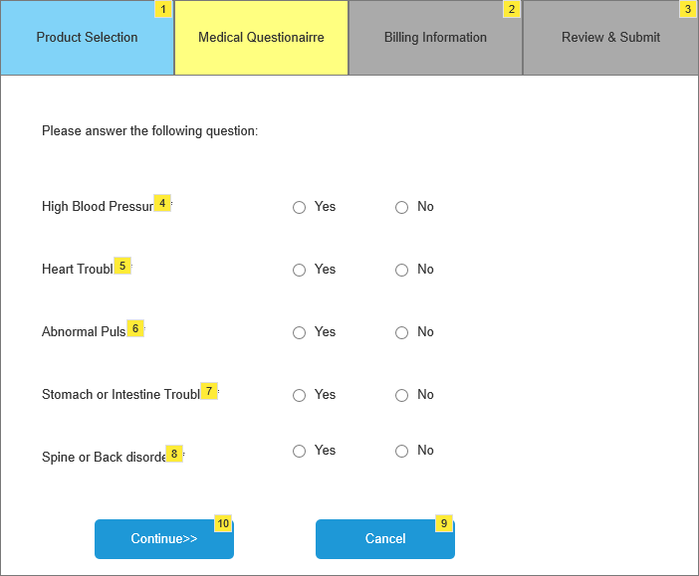

* + 1. Widget Table

|  |  |  |  |
| --- | --- | --- | --- |
| Note number | Name | Interactions | Note |
| 1 | Product Selection: Text box |  | Required Field  Can go back to this page to edit selection |
| 2 | Billing Information: Text Box |  | Can not go to this page without filling required data and continuing on Product selection page and Medical Questionairre page |
| 3 | Review & Submit: Text Box |  | Can not go to this page without filling required data and continuing on Product selection page and Medical Questionairre page and Billing information page |
| 4 | High Blood Pressure? : Radio Button |  | Required Field  Options are Yes and No  Can select Only one at a time |
| 5 | Heart Trouble?: Radio Button |  | Required Field  Options are Yes and No  Can select Only one at a time |
| 6 | Abnormal Pulse? : Radio Button |  | Required Field  Options are Yes and No  Can select Only one at a time |
| 7 | Stomach or Intestine Trouble? : Radio Button |  | Required Field  Options are Yes and No  Can select Only one at a time |
| 8 | Spine or Back disorder? : Radio Button |  | Required Field  Options are Yes and No  Can select Only one at a time |
| 9 | Cancel : Command Button |  | On click discard all the entered data and display log in page |
| 10 | Continue>>: Command Button |  | On click if all validation pass display Billing Information page else display error message |

* 1. Billing Information
     1. User Interface

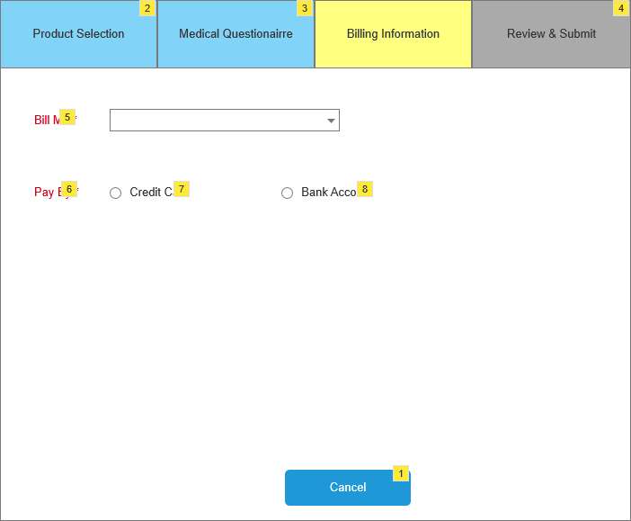

* + 1. Widget Table

|  |  |  |  |
| --- | --- | --- | --- |
| Note number | Name | Interactions | Note |
| 1 | Cancel: Command Button |  | On click discard all the entered data and display log in page |
| 2 | Product Selection: Text Box |  | Required Field  Can go back to this page to edit selection |
| 3 | Medical Quiestionairre |  | Required Field  Can go back to this page to edit selection |
| 4 | Review & Submit : Text Box |  | Can not go to this page without filling required data and continuing on Product selection page and Medical Questionairre page and Billing information page |
| 5 | Bill Me : Drop down |  | Required Field  Options are Given  NO default selection |
| 6 | Pay By: Radio Button |  | Required Field  Options are Credit card / Bank account  Only can choose one at a time |
| 7 | Credit Card : Radio Button |  | On click display Credit card page |
| 8 | Bank Account : Radio Button |  | On click display Bank Account Page |

* 1. Bank Account
     1. User Interface

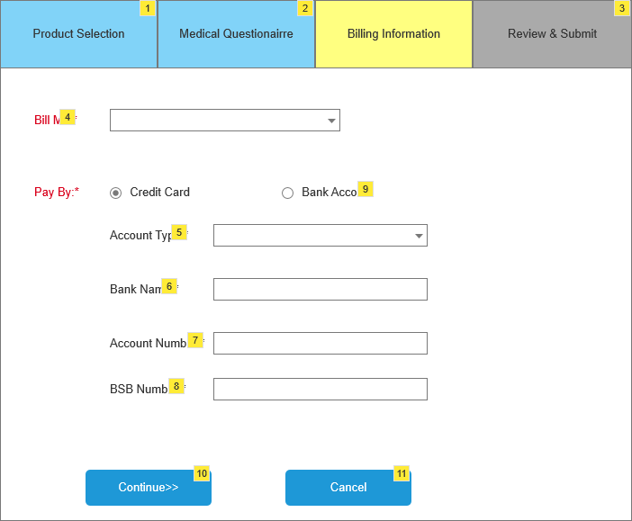

* + 1. Widget Table

|  |  |  |  |
| --- | --- | --- | --- |
| Note number | Name | Interactions | Note |
| 1 | Product Selection : Text Box |  | Required Field  Can go back to this page to edit selection |
| 2 | Medical Questionairre |  | Required Field  Can go back to this page to edit selection |
| 3 | Review & Submit |  | Can not go to this page without filling required data and continuing on Product selection page and Medical Questionairre page and Billing information page |
| 4 | Bill me: Drop Down |  | Required Field  Options are Given  NO default selection |
| 5 | Account Type : Drop Down List |  | Required Field  Options are Savings and Checkings  Can select one at a time |
| 6 | Bank Name: Text Box |  | Required Field  Alphabatical Data  Min. char 2  Max. char 56 |
| 7 | Account Number: Text Box |  | Required Field  Numerical Data  Min. char 8  Max. char 8 |
| 8 | BSB Number : Text Box |  | Required Field  Numeric Data  Min. char 6  Max. char 6 |
| 9 | Bank account : Radio Button |  | On click discard all the entered data and display Bank Account Page |
| 10 | Continue>>: Command Button |  | On click if all validation pass display Review & Submit page else display error message |
| 11 | Cancel : Command Button |  | On click discard all the entered data and display Log in page |

* 1. Credit card
     1. User Interface

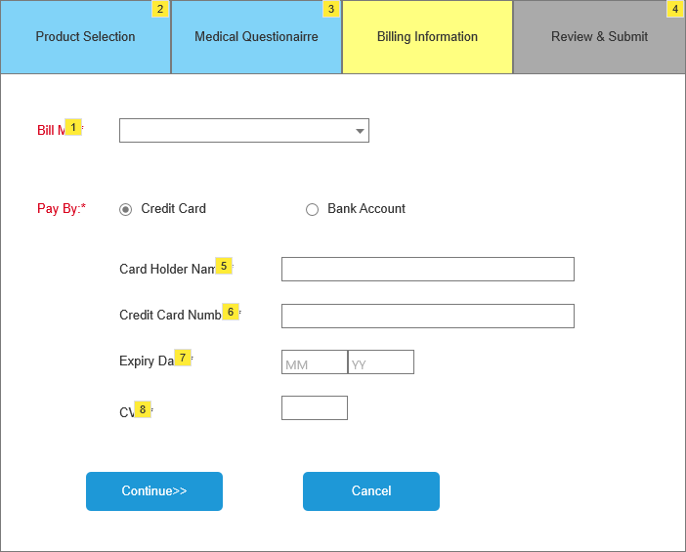

* + 1. Widget Table

|  |  |  |  |
| --- | --- | --- | --- |
| Note number | Name | Interactions | Note |
| 1 | Bill me : Drop Down |  | Required Field  Options are Given  NO default selection |
| 2 | Product Selection: Text Box |  | Required Field  Can go back to this page to edit selection |
| 3 | Medical Questionairre |  | Required Field  Can go back to this page to edit selection |
| 4 | Review & Submit |  | Can not go to this page without filling required data and continuing on Product selection page and Medical Questionairre page and Billing information page |
| 5 | Card Holder Name: Text Box |  | Required Field  Alphabatical Data  Min. char 2  Max. char 56 |
| 6 | Credit Card Number: Text Box |  | Required Field  Numerical Data  Min. char 16  Max. char 16 |
| 7 | Expiry Date |  | Required Field  Numerical Data  Min. char 2  Max. char 2 |
| 8 | CVV : Text Box |  | Required Field  Numerical Data  Min. char 3  Max. char 3 |

* 1. Review & Submit
     1. User Interface

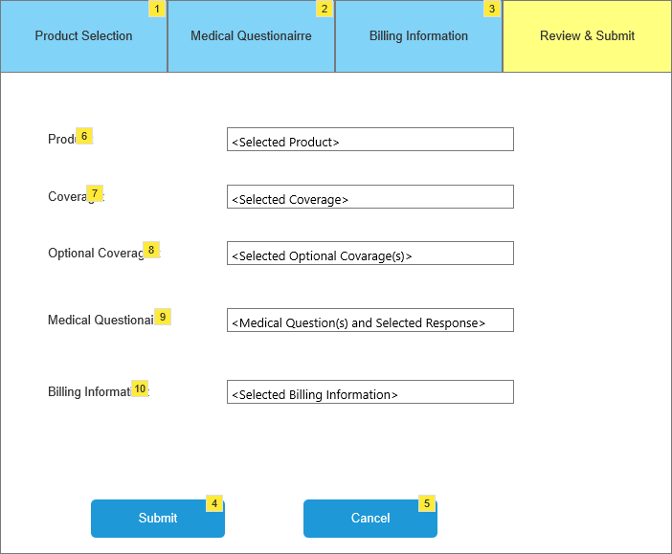

* + 1. Widget Table

|  |  |  |  |
| --- | --- | --- | --- |
| Note number | Name | Interactions | Note |
| 1 | Product Selection : Text Box |  | Required Field  Can go back to this page to edit selection |
| 2 | Medical Questionairre : Text Box |  | Required Field  Can go back to this page to edit selection |
| 3 | Billing Information : Text Box |  | Required Field  Can go back to this page to edit selection |
| 4 | Submit : Command Button |  | On click if all validation pass display Log In page else display error message |
| 5 | Cancel : Command Button |  | On click discard all the entered data and display Log In page |
| 6 | Product : Text Box |  | Can see the selected product but can not edit here |
| 7 | Covarage : Text Box |  | Can see the selected Covarage but can not edit here |
| 8 | Optional Covareges : Text Box |  | Can see the selected optional covarages but can not edit here |
| 9 | Medical Questionairre : Text Box |  | Can see the selected Medical questionairre but can not edit here |
| 10 | Billing Information : Text Box |  | Can see the selected billing information but can not edit here |